Campus Community Group Schedule
Fall 2018
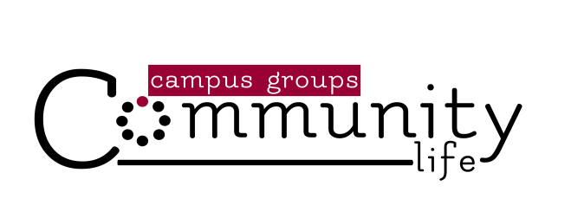
Fall Kick off (September 9)
Groups launch for Fall & SeptemberFest!

Global Mission’s Week (October 14-21)

The Art of Neighboring Group Study begins (November 4-December 16)

Family Serving Project (November 17)

Groups will not Meet (November 25) Thanksgiving

Groups will not Meet (December 23 & 30) Christmas & New Years

Looking Ahead …

CBC Equipping Summit on Sharing our Faith in a Multi-Cultural World (January 26)

Date Night (March 30) Hold the date … and pray about a couple to invite!
Revised 8.29.18

